**Linked server**

**Setting up a linked server between two SQL Server instances (henok and henok\test)**

**Create the Linked Server**:

* In SSMS, expand the **Server Objects** node in Object Explorer.
* Right-click **Linked Servers** and choose **New Linked Server**.

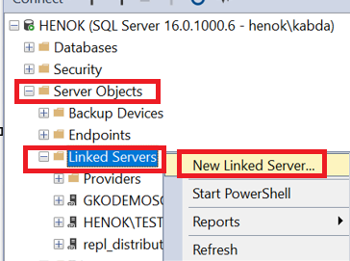

**Linked Server Properties**:

* **Linked Server**: Enter the name for the linked server. This can be any name you choose.
* **Server Type**: Choose **SQL Server**.
* **Server Name**: Enter Henok\Test (the name of the instance you want to link to).

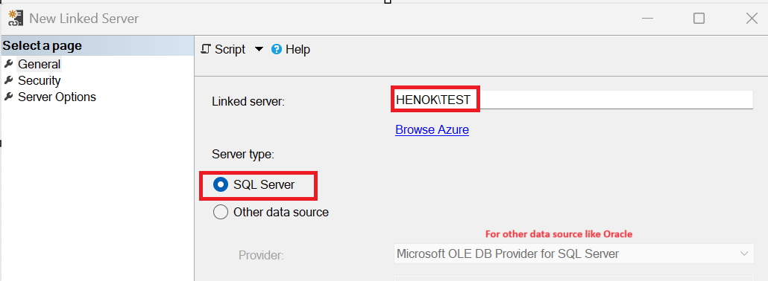

**Security**: Configure the security settings under the **Security** tab.

* **Be made using this security context**: Use this if you want to specify a SQL Server login for the connection. Provide the login and password for a user on henok\test.
* **Impersonate**: This option allows the linked server to use the credentials of the currently connected user. This requires that the user has access to both instances.

The SQL LOGIN **must exist in the destination** (henok\test) with necessary permissions to access database. If it is given db_reader permission to admin database, it can’t do write. If the permission is only for admin database, it can’t access other databases.

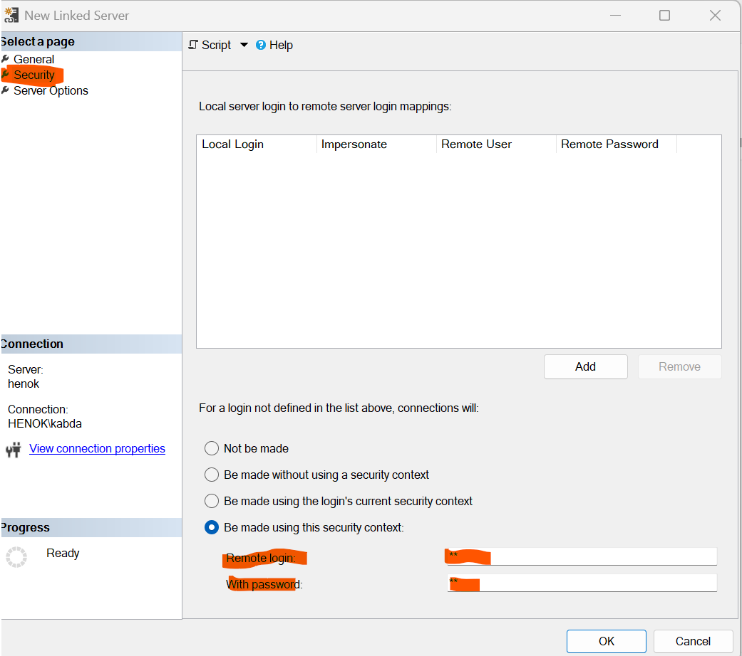

**Provider Options**: If needed, adjust provider options under the **Server Options** tab.

* Ensure that **RPC** and **RPC Out** are set to True if you plan to run stored procedures on the remote server.

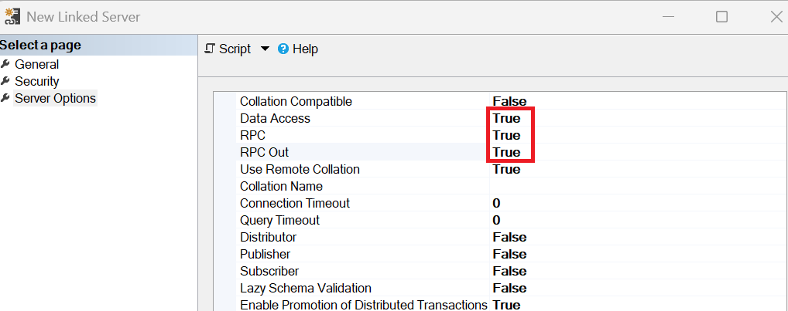

**Test the Connection**: After configuring the linked server, test the connection by expanding the linked server node in Object Explorer or running a test query.

**Test with a Simple Query**:

SELECT * FROM [LinkedServerName].[DatabaseName].[SchemaName].[TableName]

**Troubleshooting**

server ABC\TESTENV' is not configured for DATA ACCESS.

Go to security and enable it by changing “Data Access” to TRUE.